Work on Multiple Computers
Use this when converting an already-started repo to the “portable Eclipse” setup.

On your other computer
- Clone the repo using GitHub Desktop
- In Eclipse on that computer switch your workspace to the EclipseWorkspace folder in your cloned git repo.
- Then File > Import -> General - > Existing Projects into Workspace
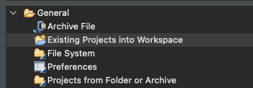
- Root directory = the cloned EclipseWorkspace repo folder. Then click finish
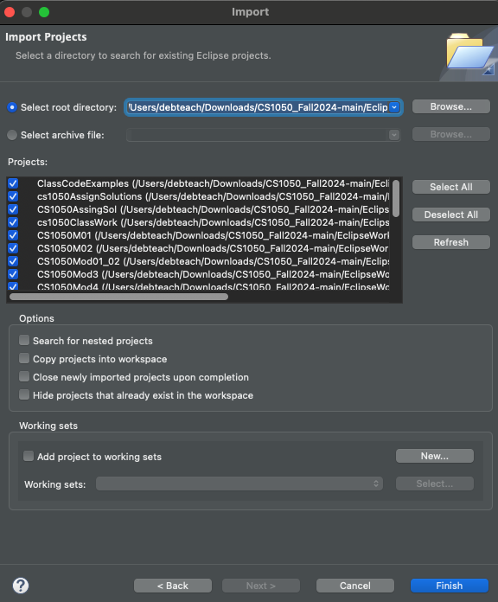
- YOu should be able to run your java code on the other computer. If you see “Unbound JRE System Library”:
  - Window > Preferences > Java > Installed JREs → Add your local JDK 22.
  - Right-click project > Build Path > Configure Build Path > Libraries > JRE System Library > Edit… → pick Execution Environment (JavaSE-22).
  - Project > Clean…

Going Forward: Adding New Projects (Cheat Sheet)
Use this every time you create a new Eclipse Java project in a repo, so it’s portable to other computers.

On the computer where you create the new project
- Create the project in Eclipse inside your repo (or move it there).
- Set portable JRE: Build Path > JRE System Library > Edit… → Execution Environment (JavaSE-17/22).
- Commit & push:

On any other computer (first time only for this project)
- git pull
- Eclipse → File > Import… > Existing Projects into Workspace → select the repo folder → Finish.
- Fix JRE binding if prompted (Execution Environment), then Project > Clean….

After the first import
- For code changes: just git pull; no re-import needed.
- If you add another new project later: repeat the “On the computer where you create the new project” steps once, and then import that new project one time on other computers.

Quick Troubleshooting
- Project not appearing in Import wizard: Confirm .project is in that project’s folder; make sure you selected Existing Projects into Workspace, not “File System.”
- macOS shows no hidden files: Press Cmd+Shift+. in Finder to see files that start with a dot.
- Case sensitivity issues (Linux): Ensure package and file names match exactly (e.g., Book.java in library package → folder must be library/, not Library/).
- Old ignore rules still winning: If .project or .classpath refuse to stage, remove any global Git ignore entries or re-create them and run git add -f once.

